**Course: Advance Bio Informatics**

**Module Title: Drug Discovery Methods**

**Module No: 119**

**Methods of DD**

**Past:**

(i) Identification of active ingredient from traditional remedies

(2) serendipitous discovery.

**Current:**

Diseases are controlled at molecular & physiological level.

Information of Human Genome

Traditionally many drugs and other chemicals with biological activity have been discovered by studying allelopathy - chemicals that organisms create that affect the activity of other organisms in the fight for survival.

Despite the rise of combinatorial chemistry as an integral part of lead discovery process, natural products still play a major role as starting material for drug discovery. A 2007 report found that of the 974 small molecule new chemical entities developed between 1981 and 2006, 63% were natural derived or semi synthetic derivatives of natural products. For certain therapy areas, such as antimicrobials, antineoplastics, antihypertensive and anti-inflammatory drugs, the numbers were higher. In many cases, these products have been used traditionally for many years.

Natural products may be useful as a source of novel chemical structures for modern techniques of development of antibacterial therapies.

Despite the implied potential, only a fraction of Earth’s living species has been tested for bioactivity.

**Plant-derived**

Prior to Paracelsus, the vast majority of traditionally used crude drugs in Western medicine were plant-derived extracts. This has resulted in a pool of information about the potential of plant species as an important source of starting material for drug discovery. A different set of metabolites is sometimes produced in the different anatomical parts of the plant (e.g. root, leaves and flower), and botanical knowledge is crucial also for the correct identification of bioactive plant materials.

**Microbial metabolites**

Microbes compete for living space and nutrients. To survive in these conditions, many microbes have developed abilities to prevent competing species from proliferating. Microbes are the main source of antimicrobial drugs. Streptomyces species have been a valuable source of antibiotics. The classical example of an antibiotic discovered as a defense mechanism against another microbe is the discovery of penicillin in bacterial cultures contaminated by Penicillium fungi in 1928.

**Marine invertebrates**

Marine environments are potential sources for new bioactive agents. Arabinose nucleosides discovered from marine invertebrates in 1950s, demonstrating for the first time that sugar moieties other than ribose and deoxyribose can yield bioactive nucleoside structures. However, it was 2004 when the first marine-derived drug was approved. The cone snail toxin ziconotide, also known as Prialt, was approved by the Food and Drug Administration to treat severe neuropathic pain. Several other marine-derived agents are now in clinical trials for indications such as cancer, anti-inflammatory use and pain. One class of these agents is bryostatin-like compounds, under investigation as anti-cancer therapy.

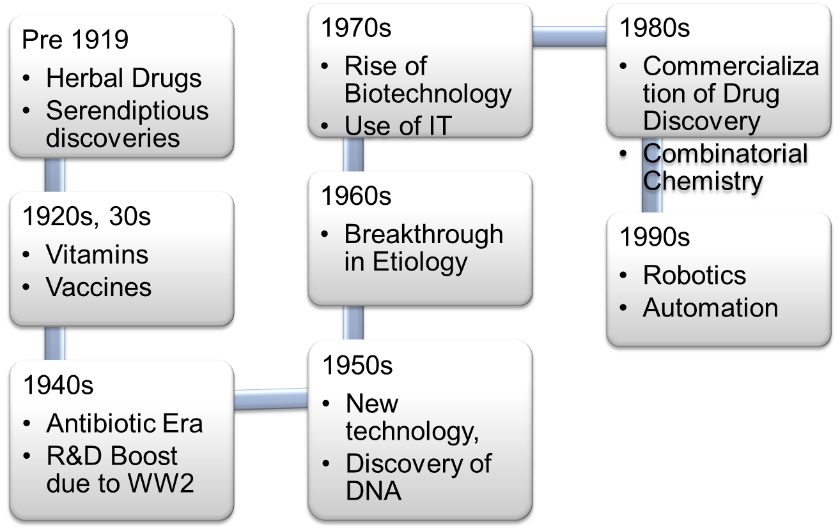

**Chemical diversity of natural products**

As above mentioned, combinatorial chemistry was a key technology enabling the efficient generation of large screening libraries for the needs of high-throughput screening. However, now, after two decades of combinatorial chemistry, it has been pointed out that despite the increased efficiency in chemical synthesis, no increase in lead or drug candidates has been reached. This has led to analysis of chemical characteristics of combinatorial chemistry products, compared to existing drugs or natural products. The chemoinformatics concept chemical diversity, depicted as distribution of compounds in the chemical space based on their physicochemical characteristics, is often used to describe the difference between the combinatorial chemistry libraries and natural products. The synthetic, combinatorial library compounds seem to cover only a limited and quite uniform chemical space, whereas existing drugs and particularly natural products, exhibit much greater chemical diversity, distributing more evenly to the chemical space. The most prominent differences between natural products and compounds in combinatorial chemistry libraries is the number of chiral centers (much higher in natural compounds), structure rigidity (higher in natural compounds) and number of aromatic moieties (higher in combinatorial chemistry libraries). Other chemical differences between these two groups include the nature of heteroatoms (O and N enriched in natural products, and S and halogen atoms more often present in synthetic compounds), as well as level of non-aromatic instauration (higher in natural products). As both structure rigidity and chirality are both well-established factors in medicinal chemistry known to enhance compounds specificity and efficacy as a drug, it has been suggested that natural products compare favorable to today's combinatorial chemistry libraries as potential lead molecules.

The idea that the effect of a drug in the human body is mediated by specific interactions of the drug molecule with biological macromolecules, (proteins or nucleic acids in most cases) led scientists to the conclusion that individual chemicals are required for the biological activity of the drug. This made for the beginning of the modern era in pharmacology, as pure chemicals, instead of crude extracts, became the standard drugs. Examples of drug compounds isolated from crude preparations are morphine, the active agent in opium, and digoxin, a heart stimulant originating from Digitalis lanata. Organic chemistry also led to the synthesis of many of the natural products isolated from biological sources.

Historically substances, whether crude extracts or purified chemicals were screened for biological activity without knowledge of the biological target. Only after an active substance was identified was an effort made to identify the target. This approach is known as classical pharmacology, forward pharmacology, or phenotypic drug discovery.

Later, small molecules were synthesized to specifically target a known physiological/pathological pathway, rather than adopt the mass screening of banks of stored compounds. This led to great success, such as the work of Gertrude Elion and George H. Hitchings on purine metabolism, the work of James Black on beta blockers and cimetidine, and the discovery of statins by Akira Endo. Another champion of the approach of developing chemical analogues of known active substances was Sir David Jack at Allen and Hanbury's, later Glaxo, who pioneered the first inhaled selective beta2-adrenergic agonist for asthma, the first inhaled steroid for asthma, ranitidine as a successor to cimetidine, and supported the development of the triptans.

Gertrude Elion, working mostly with a group of fewer than 50 people on purine analogues, contributed to the discovery of the first anti-viral; the first immunosuppressant (azathioprine) that allowed human organ transplantation; the first drug to induce remission of childhood leukaemia; pivotal anti-cancer treatments; an anti-malarial; an anti-bacterial; and a treatment for gout.

Cloning of human proteins made possible the screening of large libraries of compounds against specific targets thought to be linked to specific diseases. This approach is known as reverse pharmacology and is the most frequently used approach today

**Methods of Drug Discovery**

It has following

* + Random Screening
  + Molecular Manipulation
  + Molecular Designing
  + Drug Metabolites
  + Serendipity

**Random Screening**

Higher/crude plants, opium, senna, reserpine, etc. Penicillin microorganism Antibacterial with improved therapeutic profiles.

**Molecular Manipulation**

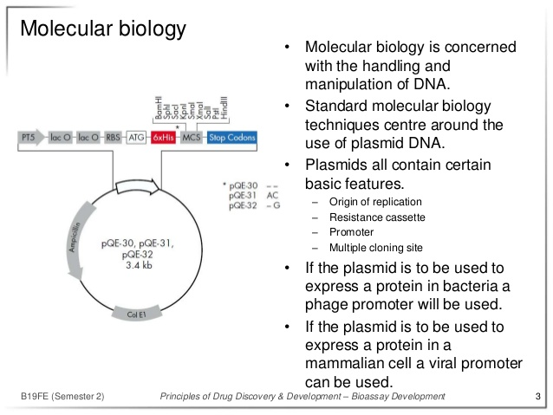

**Drug Metabolism**

Xenobiotic metabolism, Biochemical modification of pharmaceutical substances or xenobiotics by living organisms, usually through specialized enzymatic systems

Lipophilic chemical compounds into more readily excreted hydrophilic products. Rate of metabolism determines duration & intensity of a drug's pharmacological action

**Serendipity**

Prototype psychotropic drugs

Development of psychiatry

Finding of one thing while looking for something else